



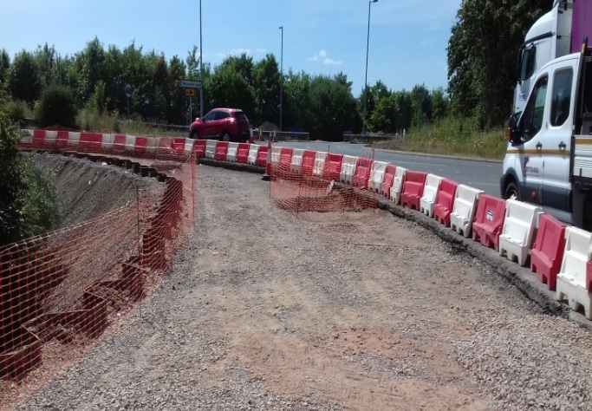
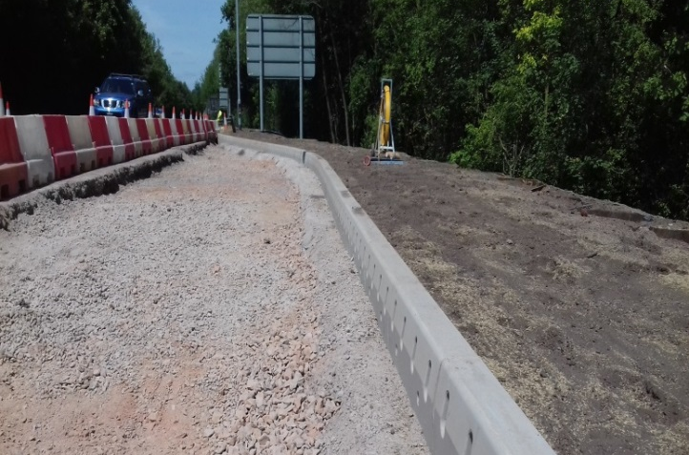
The scheme to improve capacity of the A40 / A417 Over Roundabout has continued in recent weeks.

Works have included:
A417 East bank kerb drainage
A40 South bank preparation for resurfacing
- Completion of East bank Kerb drainage, Landscaping of verge.
- Completion of ducting A417 Maisemore road
- Installation of Lamp columns to East side of A417 Maisemore road.
- Installation of Manhole chambers A40 south bank.
Planned works for the next two weeks include
- Verge preparation for resurfacing
- Drainage & ducting work

We are programmed to complete the full resurfacing of the roundabout over the first two weekends of August. Road closures will be in place as below:
- Friday 3rd August 19:00 - Monday 6th 06:00 to resurface the northern section.
Travel will only be permitted through the roundabout:
Eastbound from Highnam to Longford
From the city westbound to Highnam (via the A417 Slip).

- Friday 10th August 19:00 - Monday 13th 06:00 to resurface the southern section.
Travel will be only be permitted through the roundabout:
Eastbound from Highnam to Longford
From Highnam to Maisemore
From Maisemore to Longford
From the city westbound to Highnam (via the A417 Slip).
Further information on the closures is available on the county council website.
Please use this QR code to find out more via the Britannia website
or use the below link for access to the GCC website:
http://www.gloucestershire.gov.uk/A40-Over

If you have any concerns or issues regarding the roundabout improvement scheme, please contact me. I will be available throughout the construction phase to provide continuous liaison and engagement with both businesses and residents within the local area.
Simon Cutter
Site Supervisor
Britannia Construction Ltd.
mailto:simon.cutter@britanniaconstruction.co.uk

